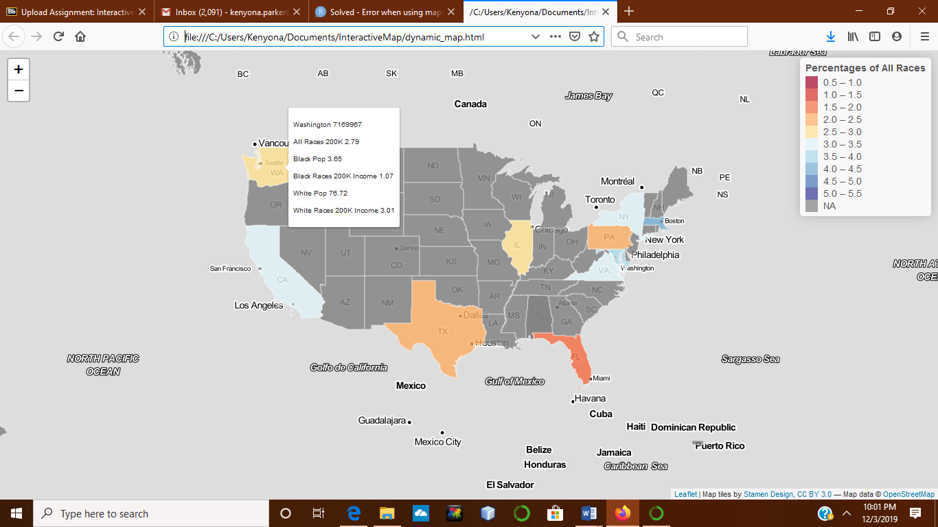

Screen shot of interactive map that is a choropleth map of the 10 states that was highlighted in our group. The map has a hover tool that shows the percentages of wages earned of 200k or more by race along with the total population for that state.